1.0 PURPOSE

This Advisory Circular (AC) is issued to provide general information and guidance on the Five Phase process applied in the certification and approval of organisations and operators in compliance with the Civil Aviation Regulations.

2.0 REFERENCE

  - The Civil Aviation (Air Operator Certification and Administration) Regulation, as amended

  - The Civil Aviation (Approved Maintenance Organization) Regulations, as amended.

  - The Civil Aviation (Approved Training Organisations) Regulations, as amended

3.0 THE CERTIFICATION AND APPROVAL PROCESS

  - The following certification and approval process provides for a continuous interaction, from the applicant’s initial enquiry to the issue or denial of the requested certificate/approval by the Civil Aviation Authority. It ensures that the applicant’s proposed programmes, systems, arrangements; facilities documentation, personnel and intended methods of compliance are thoroughly reviewed, evaluated, and tested.

  - There are five phases in the process for air operator and organisation certification and approval respectively. Each phase is described in sufficient detail to provide a general understanding of the entire process. (See Appendix 1 for a detailed flow chart of the entire certification or approval process). During certification, the process is followed in sequence in the order indicated below. In order to move to the next phase the preceding phase must be completed successfully.

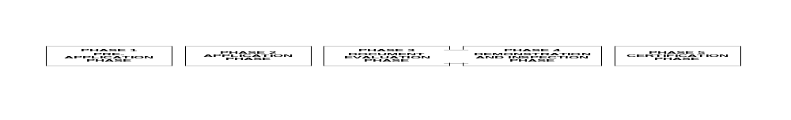

4.0 PREAPPLICATION PHASE

4.1 Pre-application Statement of Intent (PASI)

4.1.1 The PASI will be used to evaluate the complexity of the proposed operation. The Certification Process will be regarded as a project. This allows the establishment of the certification team based on the complexity of the certification. The assigned Certification Project Manager (CPM) will be designated as the principal spokesperson for the Authority during the certification process.

4.1.2 An applicant should conduct a thorough review of the Civil Aviation Regulations and other applicable Regulations and Advisory material to gain meaningful insight into personnel, facility, equipment, and documentation requirements. As a result of this review, the applicant must address, in the PASI, how these requirements will be met.

    - The applicant shall complete a relevant application form for certification or approval.

NOTE: Submission of the PASI by the applicant indicates intent to initiate the certification process.

4.2 Pre-application Meeting

During this meeting, the requirements which need to be attached to the formal application will be discussed which should include the following:

- Documentation and Manuals: The applicant should indicate all the documentations and manuals to be used in compliance with the relevant regulations and requirements for the applicable operations. The manuals should allow the user to understand its content without further explanation and must not contradict any regulatory requirements;

- Compliance Statement: The compliance statement will ensure that all applicable regulatory requirements are addressed during the certification process. This is done by listing each applicable Civil Aviation Regulations section, in numerical sequence. After each listed regulation, there must be a brief narrative or specific reference to a manual/document that describes how the applicant will comply with that regulation. The letter of compliance must be reviewed to ensure that the applicant has a clear understanding of the regulation and that the proposed method of compliance meets the intent of the regulation.

4.3 Personnel Requirements

Personnel requirements will include among others;

- Key personnel
- Their qualifications
- Training requirements
- Human factor and human performance issues appropriate to the function of that person in the organisation etc

5.0 FORMAL APPLICATION PHASE

To begin the Formal Application Phase the team will receive the application letter and attachments. As a rule, the team will meet with the applicant after receiving the formal application package. All questions about the proposed operation, the formal application and attachments should be resolved at this time. The meeting should consist of the certification team members and all key management personnel from the applicant’s organization.

6.0 DOCUMENT EVALUATION PHASE

In this phase, the applicant’s manuals and other related documents and attachments are carefully and thoroughly reviewed and either approved, accepted or rejected. This review ensures both conformity to the applicable Regulations and safe operating practices. The certification team members will conduct evaluation of the submitted document/manuals in the office.

7.0 DEMONSTRATION AND INSPECTION PHASE

In this phase the certification team will conduct a thorough audit at the applicant’s premises to ensure that the applicant’s proposed procedures are effective and that facilities and equipment are in place and meet regulatory requirements. The demonstration phase is carried out after satisfactory document evaluation phase.

8.0 CERTIFICATION PHASE

Once the applicant meets the regulatory requirements of the Civil Aviation Regulations, the Authority will issue a certificate with the appropriate applicant’s specifications and ratings.

9.0 CERTIFICATE VALIDITY

Certificates are issued up to a 12 months period after initial certification or renewal. The certificates remain valid so long as the established standards at certification are maintained and complied with.

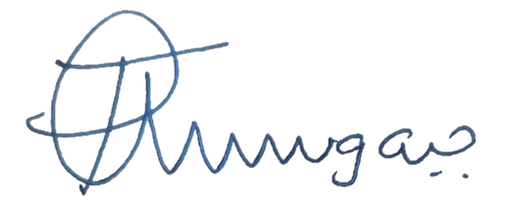

______________________
Director Safety Regulation

APPENDIX 1 - CERTIFICATION PROCESS FLOW CHART.  Phase 1 of 5  The flow charts on the following pages are representative of the Air Operator Certification Process. This chart also represents the process for the certification of an Approved Maintenance Organisation. | 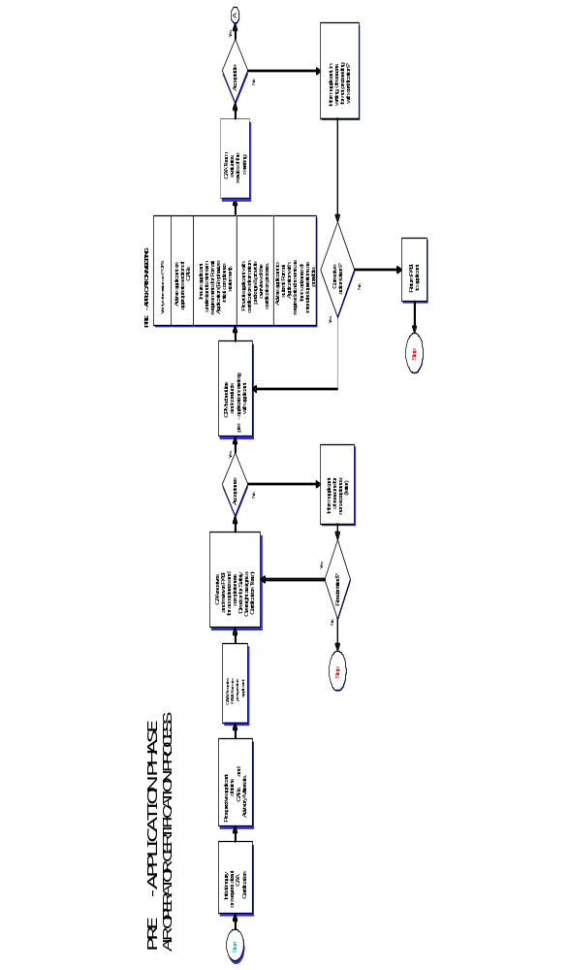
APPENDIX 1 - CERTIFICATION PROCESS FLOW CHART.  Phase 2 of 5 | 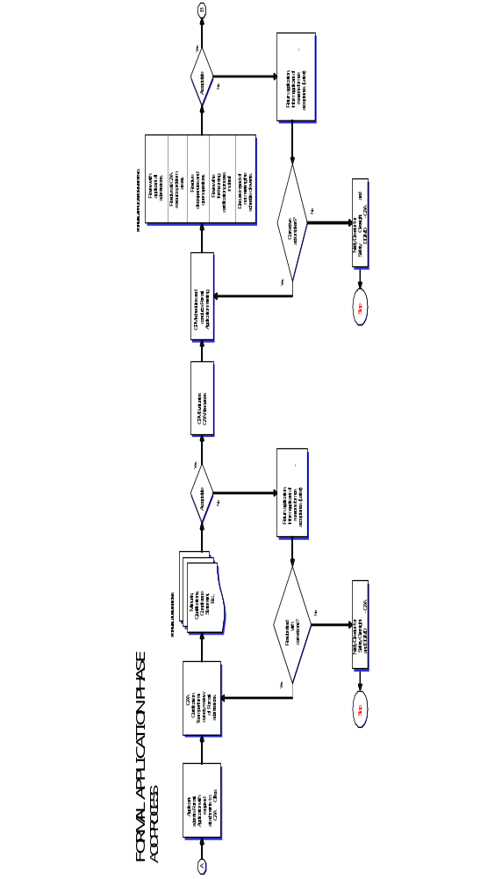
APPENDIX 1 - CERTIFICATION PROCESS FLOW CHART.  Phase 3 of 5 | 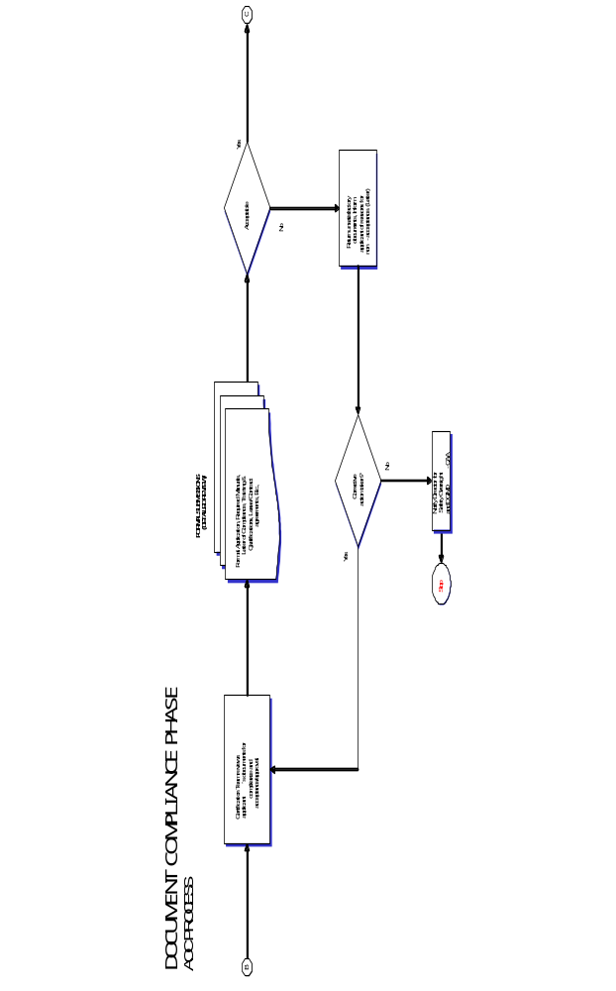
APPENDIX 1 - CERTIFICATION PROCESS FLOW CHART.  Phase 4 of 5 | 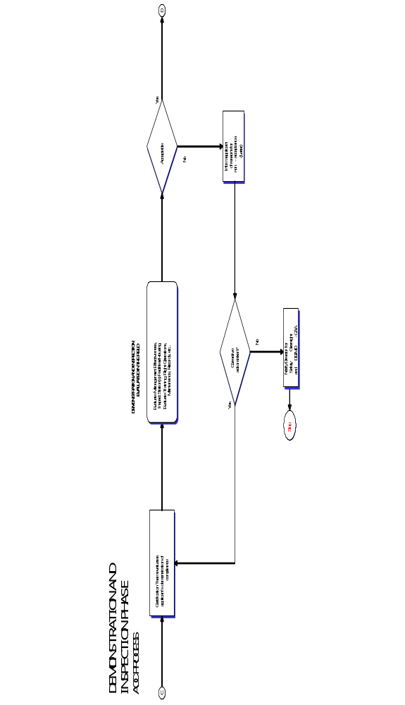
APPENDIX 1 - CERTIFICATION PROCESS FLOW CHART.  Phase 5 of 5 | 